**Guide to setting up the STS environment.**

Note. Once STS is installed on our computer, we need to specify to STS the location of our JDK (Java Development Kit) because STS, by default, will take JRE (Java Runtime Edition). This guide was prepared using STS for Windows. For Mac, the same steps have to be performed.

**Setting up JDK in STS.**

1. Navigate into the directory structure created when you unzipped STS, look for the file called SpringToolSuite4.exe and run it. It would be convenient if you made a direct access icon on your computer’s desktop so that you can execute this file directly from the desktop. Once STS is loaded, we will get the following window.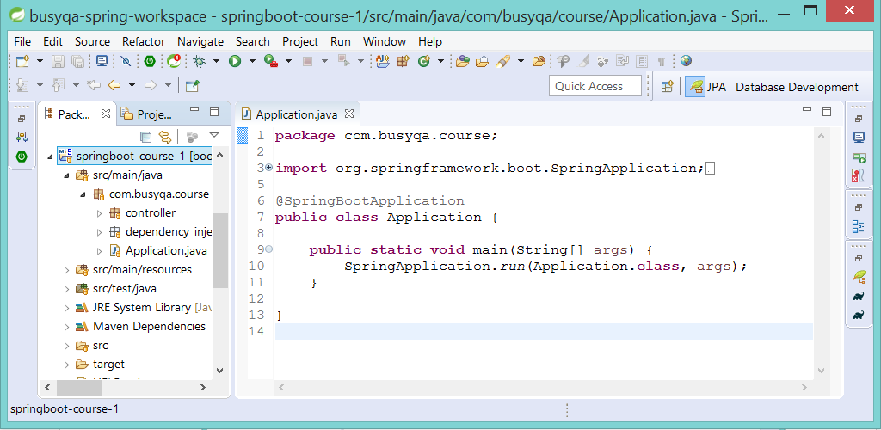
2. From the STS Menu, go to Window/Preferences. The “Preferences” window will pop up.

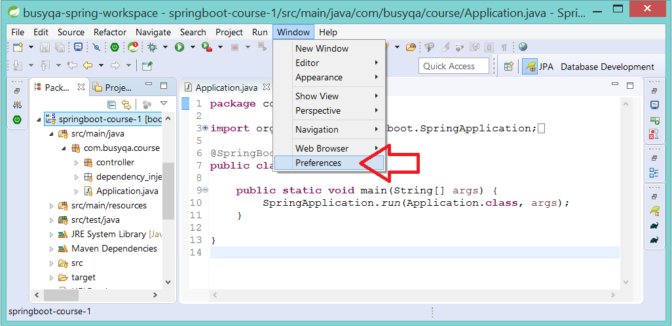

1. Within the Preferences Window, go to Java/Installed JREs. You will see that by default, JRE was installed. In the next step, we need to remove that configuration and set up JDK as our default Java definition.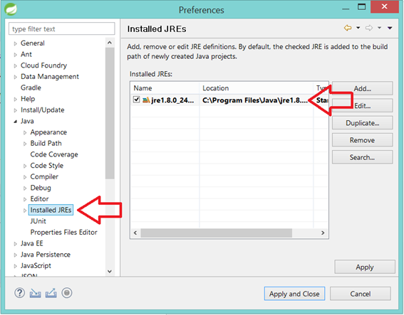
2. Make sure the JRE is selected and hit the “Remove” button.

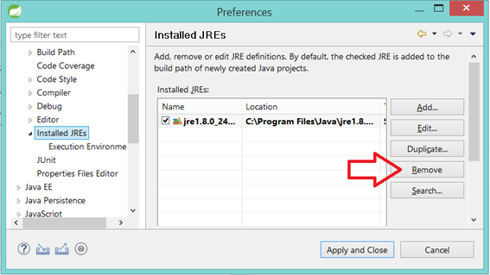

1. Once the JRE was removed, you will get an empty list. So now it’s time to set JDK up in our STS.

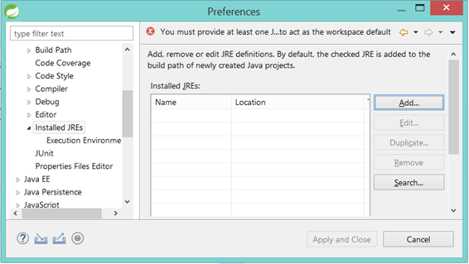

1. Go hit the “Add” button.

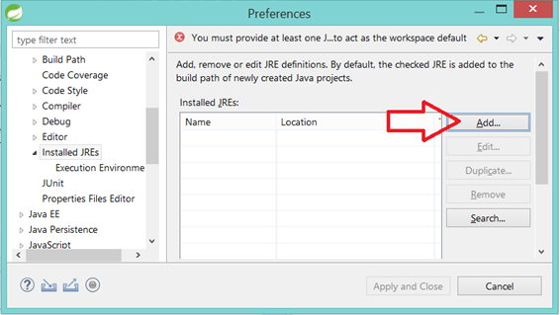

1. Select “Standard VM” and hit next.

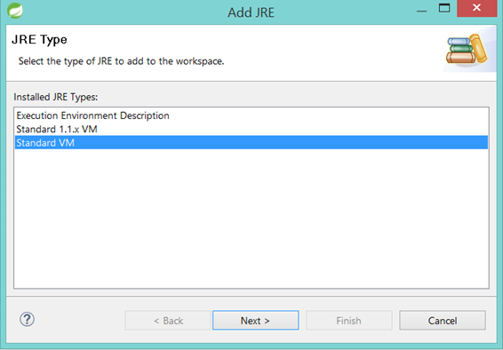

1. Hit the “Directory” button and provide the root folder of your JDK.

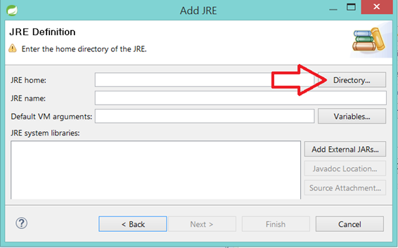

1. Your JDK should be located in C:/Program Files/Java/jdk1.8.0. Select the folder of your JDK. (Make sure you select the root folder of your JDK)

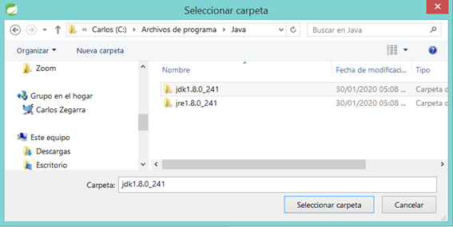

1. STS will accept the new setup and will show the following window. Hit the “Finish” button.

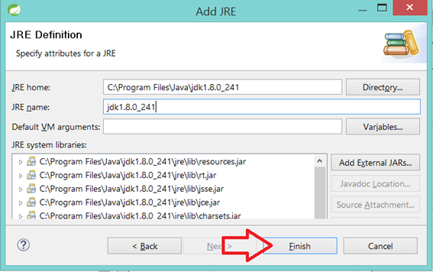

1. Finally, select JDK as your default Java definition by checking off the checkbox and hitting the “Apply and Close” button. Now you are all set!

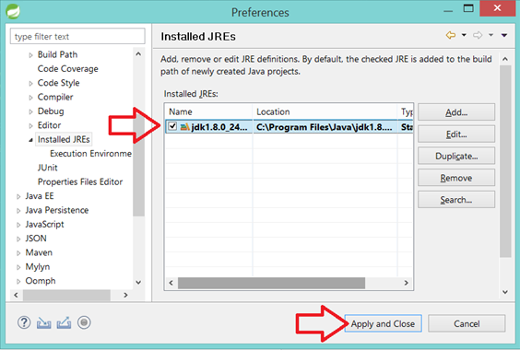

**Installing Database Development Tools in STS.**

1. From the STS Menu, go to Help/Install New Software. The “Install” window will pop up.

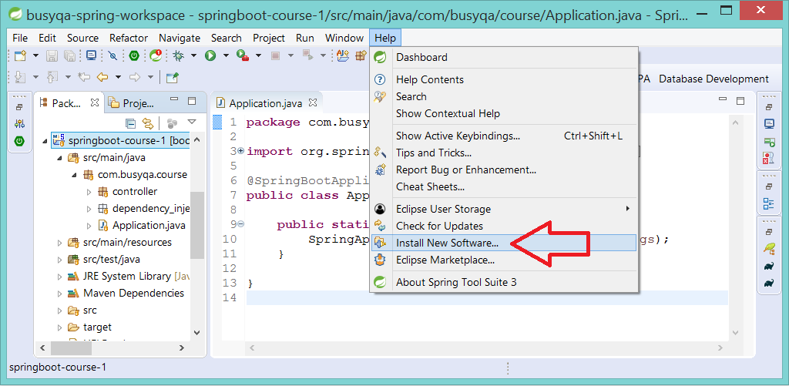

1. From the drop-down menu, pick the option that says *“All Available Sites.”* Please wait until the information is retrieved and the grid is populated with it.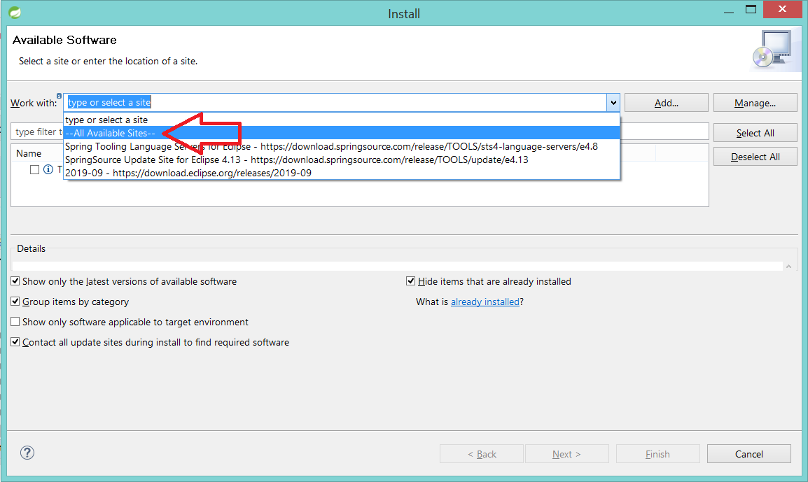
2. From the Grid, check *“Database Development”* and hit “Next.”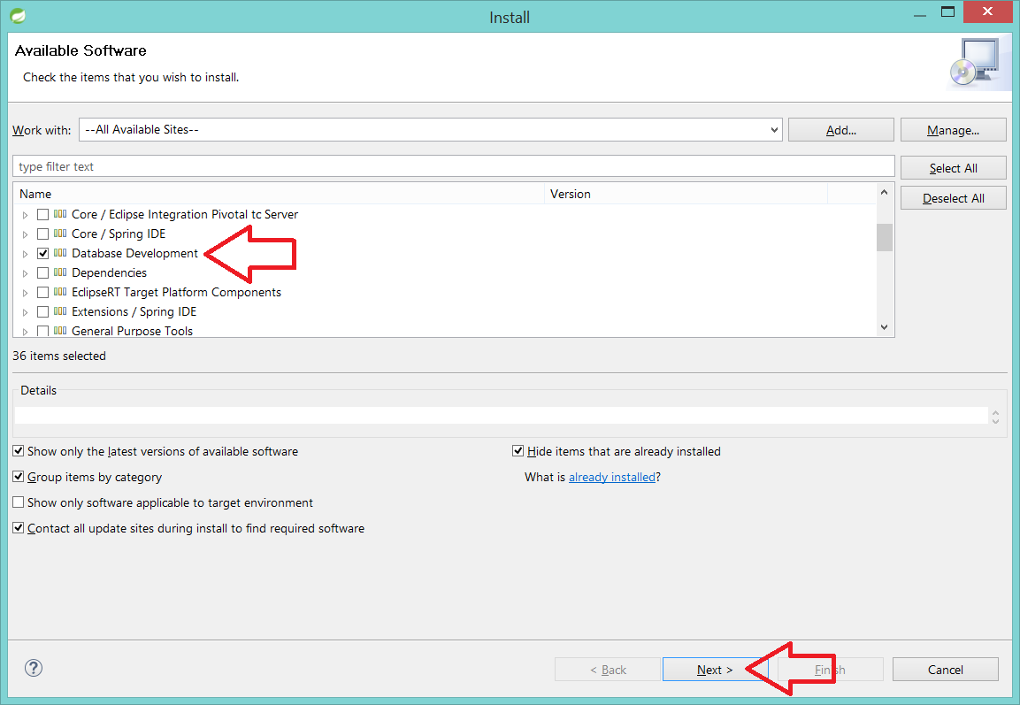
3. Hit “Next” again.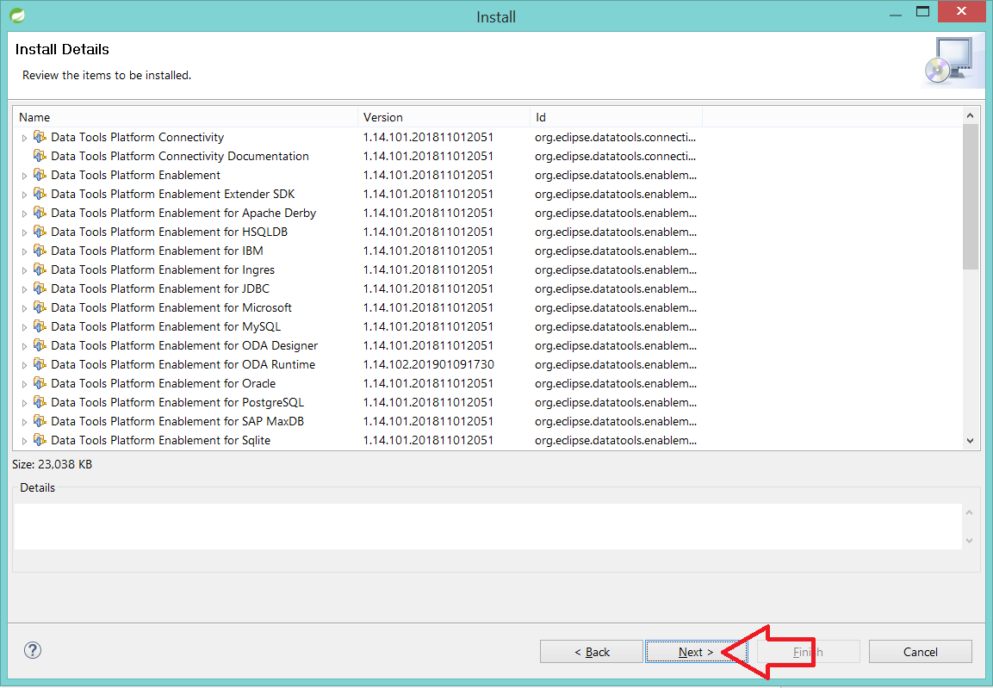
4. Accept the terms of the license and hit “Finish.”

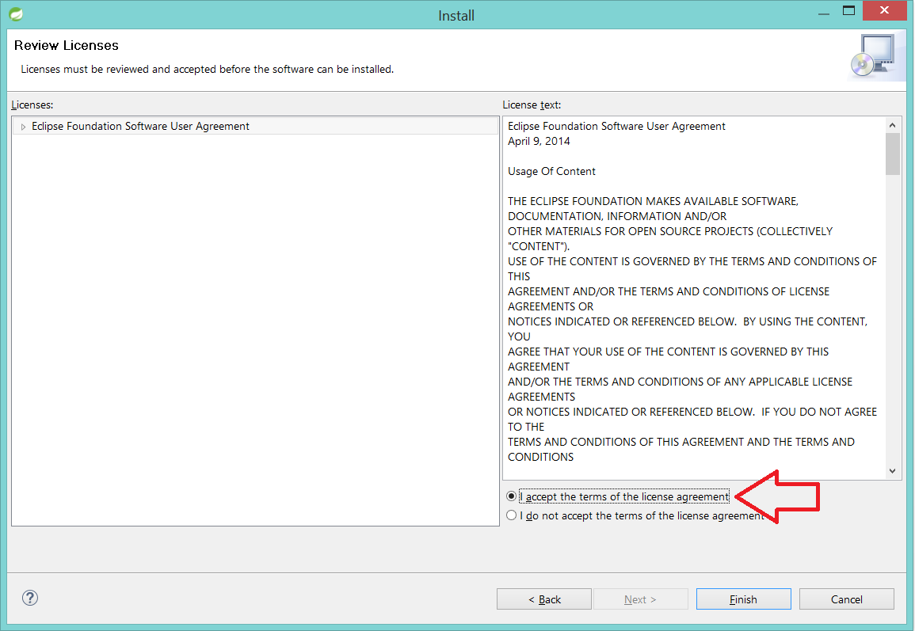

1. Wait until the installation of the software is completed. In the meantime, you will see a progress bar on the bottom-right of your IDE.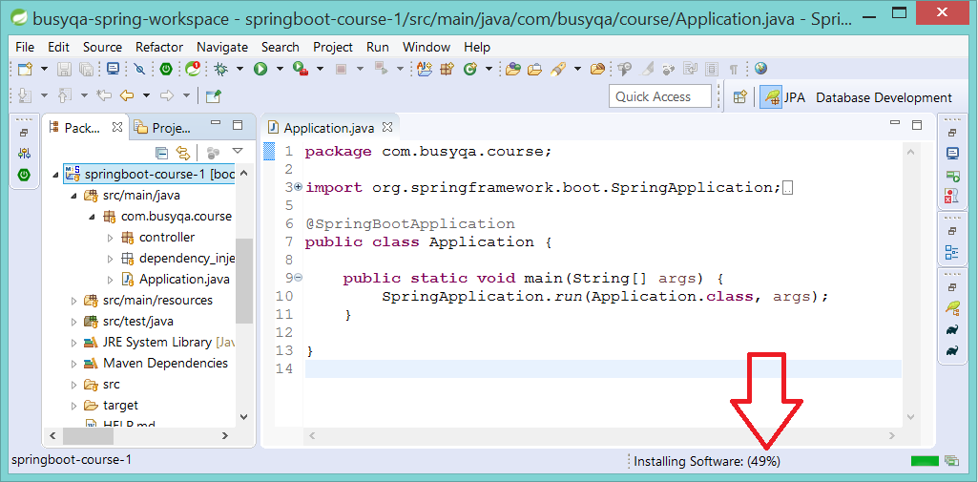
2. Once the installation is completed, restart the IDE by hitting the *“Restart Now”* button.

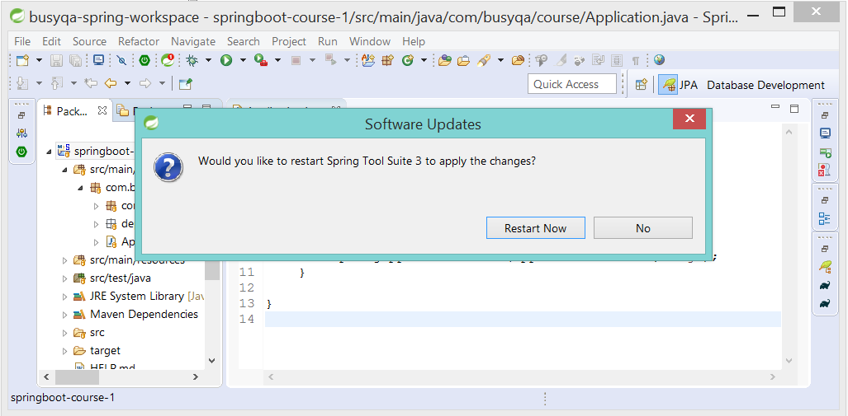

**Installing Hibernate Tools in STS.**

1. From the STS Menu, go to Help/Eclipse Marketplace. The “Eclipse Marketplace” window will pop up.

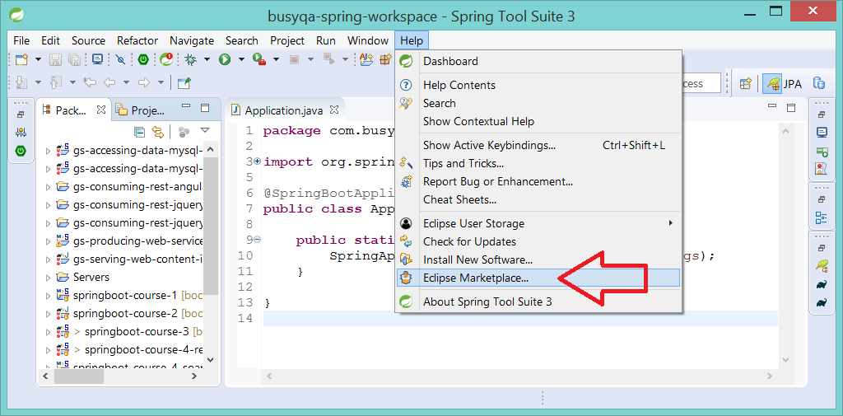

1. Type *“JBoss”* in the box as displayed in the image. Then hit the *“Go”* button. Once the grid is populated, you will see JBoss Tools in it. Hit “*Install*” to begin the installation.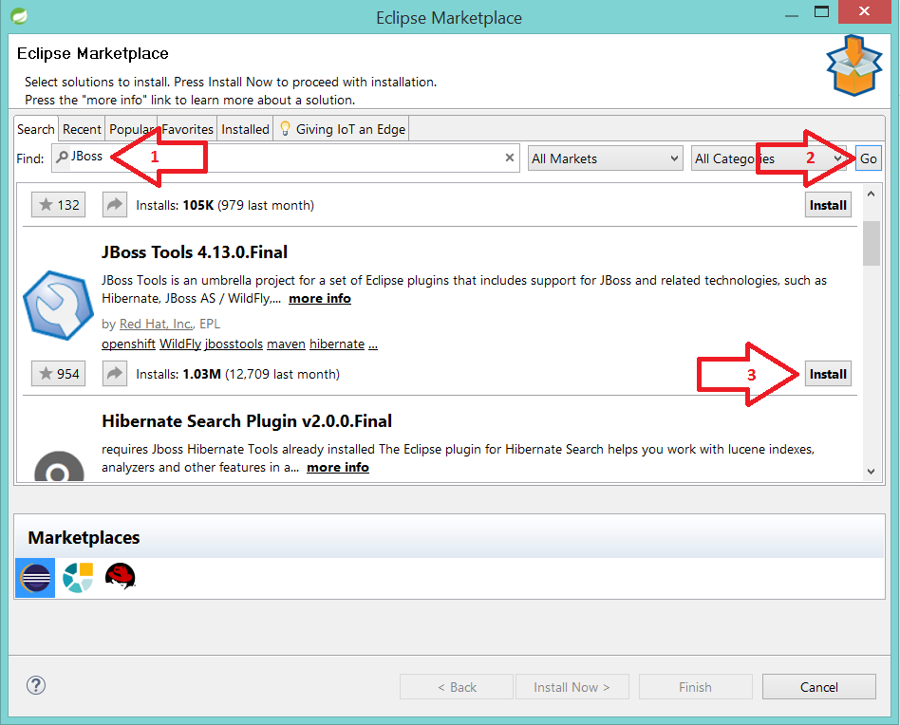
2. Check “Hibernate Tools” only from the list of components and hit *“Confirm.”* The JBoss Tools usage reporting tools are required, so leave it checked.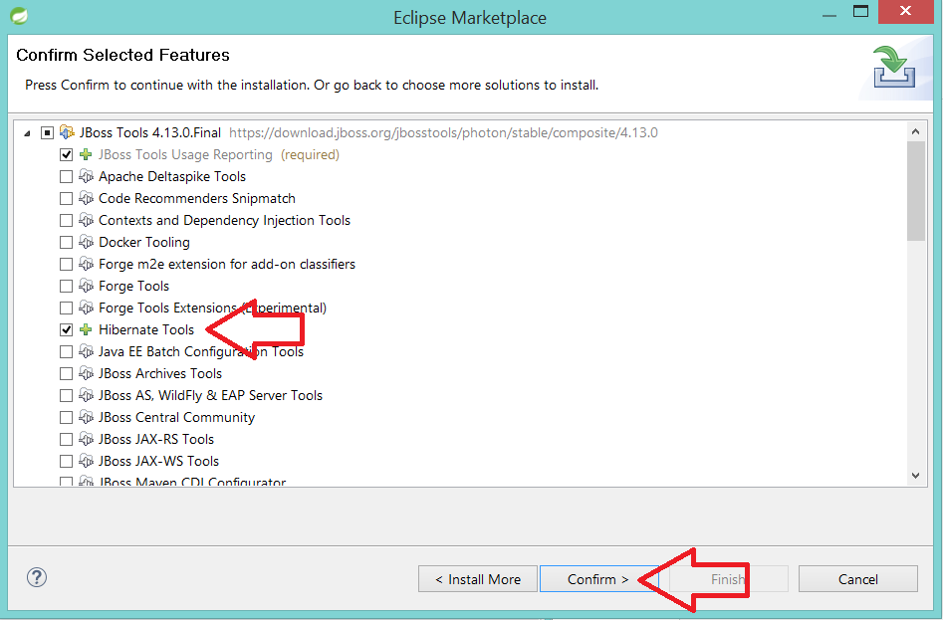
3. Accept the terms of the license and hit *“Finish.”*

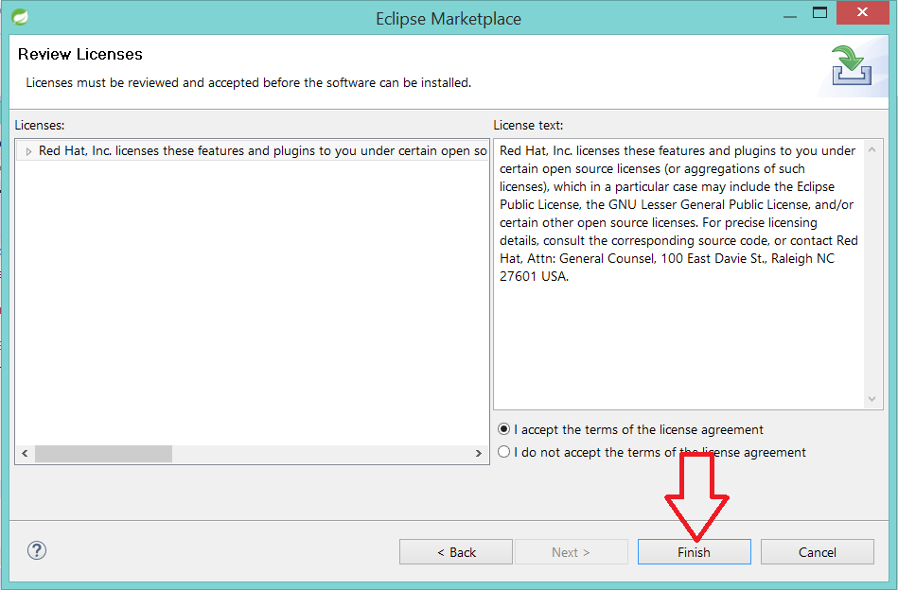

1. Wait until the installation of the software is completed. In the meantime, you will see a progress bar on the bottom-right of your IDE.

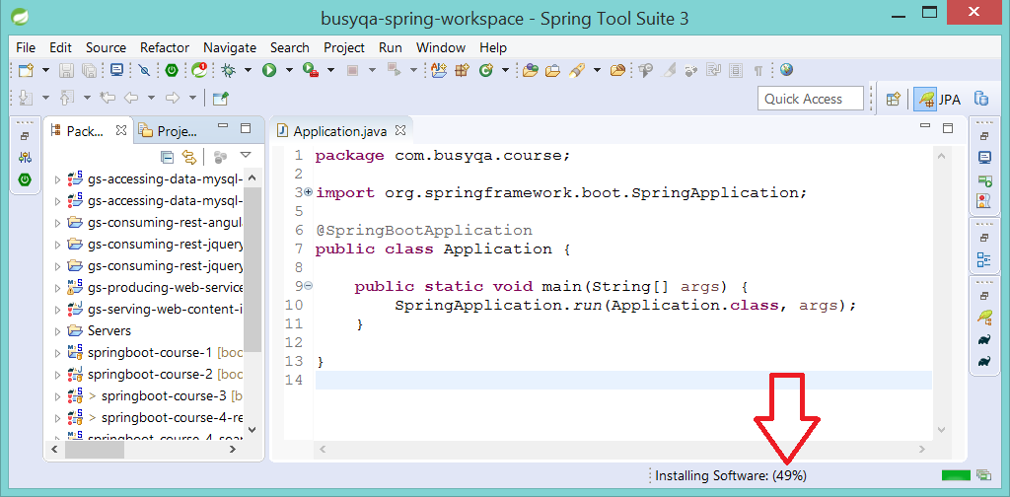

1. A warning message will pop up. Ignore it as the software we are installing is safe. Hit “*Install anyway*.”

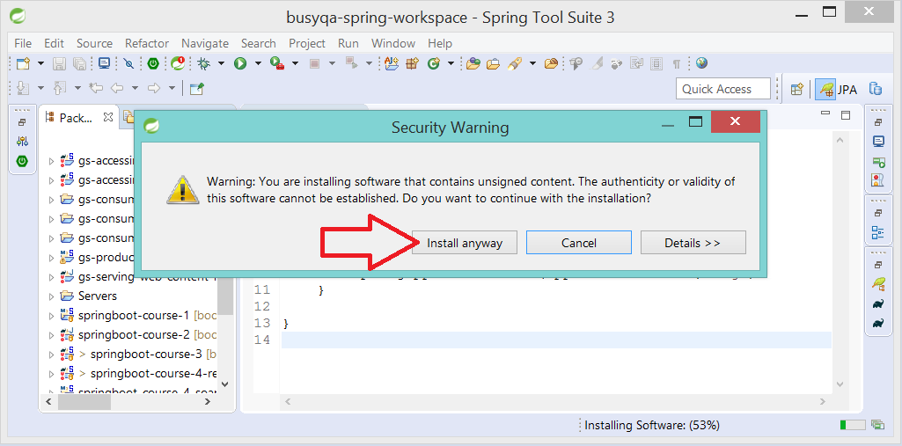

1. Once the installation is completed, you will be prompted to restart the IDE. Hit the “Restart Now” button and after the IDE is restarted, you are all set!



// End